**Title:**

*Assessing local chlamydia screening performance by combining survey and administrative data to account for differences in local population characteristics*

Nathan Green1,2,3*, Ellie Sherrard-Smith1, Clare Tanton4, Pam Sonnenberg4, Catherine H Mercer4, Peter J White1,2

**\*Corresponding author:** Nathan Green [nathan.green@imperial.ac.uk](mailto:nathan.green@imperial.ac.uk)

**Addresses:**

1. MRC Centre for Outbreak Analysis and Modelling, Department of Infectious Disease Epidemiology, School of Public Health, Faculty of Medicine, Imperial College London, Norfolk Place, London W2 1PG, UK

2. NIHR Health Protection Research Unit in Modelling Methodology, Department of Infectious Disease Epidemiology, School of Public Health, Faculty of Medicine, Imperial College London, Norfolk Place, London W2 1PG, UK

3. Modelling and Economics Unit, National Infection Service, Public Health England, London NW9 5EQ, UK

4. Centre for Sexual Health & HIV Research, Research Department of Infection and Population Health, University College London, Mortimer Market Centre, off Capper Street, London WC1E 6JB

**SUPPLEMENTARY MATERIAL**

Supporting data and additional results are given in the following sections.

|  |  |  |  |
| --- | --- | --- | --- |
| **Region** | **Local authority (LA)** | **LA number in region** | **LA number** |
| East Midlands | West Lindsey | 1 | 302 |
| East Midlands | Wellingborough | 2 | 296 |
| East Midlands | South Northamptonshire | 3 | 241 |
| East Midlands | South Kesteven | 4 | 238 |
| East Midlands | South Holland | 5 | 237 |
| East Midlands | South Derbyshire | 6 | 234 |
| East Midlands | Rutland | 7 | 218 |
| East Midlands | Rushcliffe | 8 | 216 |
| East Midlands | Oadby And Wigston | 9 | 191 |
| East Midlands | Nottingham | 10 | 189 |
| East Midlands | Northampton | 11 | 186 |
| East Midlands | North West Leicestershire | 12 | 185 |
| East Midlands | North Kesteven | 13 | 179 |
| East Midlands | North East Derbyshire | 14 | 176 |
| East Midlands | Newark And Sherwood | 15 | 170 |
| East Midlands | Melton | 16 | 160 |
| East Midlands | Mansfield | 17 | 158 |
| East Midlands | Lincoln | 18 | 151 |
| East Midlands | Leicester | 19 | 147 |
| East Midlands | Kettering | 20 | 138 |
| East Midlands | Hinckley And Bosworth | 21 | 129 |
| East Midlands | High Peak | 22 | 127 |
| East Midlands | Harborough | 23 | 116 |
| East Midlands | Gedling | 24 | 105 |
| East Midlands | Erewash | 25 | 97 |
| East Midlands | East Northamptonshire | 26 | 87 |
| East Midlands | East Lindsey | 27 | 86 |
| East Midlands | Derbyshire Dales | 28 | 76 |
| East Midlands | Derby | 29 | 75 |
| East Midlands | Daventry | 30 | 74 |
| East Midlands | Corby | 31 | 63 |
| East Midlands | Chesterfield | 32 | 56 |
| East Midlands | Charnwood | 33 | 50 |
| East Midlands | Broxtowe | 34 | 39 |
| East Midlands | Boston | 35 | 25 |
| East Midlands | Bolsover | 36 | 23 |
| East Midlands | Blaby | 37 | 20 |
| East Midlands | Bassetlaw | 38 | 15 |
| East Midlands | Ashfield | 39 | 5 |
| East Midlands | Amber Valley | 40 | 3 |
| East of England | Welwyn Hatfield | 1 | 297 |
| East of England | Waveney | 2 | 293 |
| East of England | Watford | 3 | 292 |
| East of England | Uttlesford | 4 | 284 |
| East of England | Thurrock | 5 | 277 |
| East of England | Three Rivers | 6 | 276 |
| East of England | Tendring | 7 | 272 |
| East of England | Suffolk Coastal | 8 | 260 |
| East of England | Stevenage | 9 | 254 |
| East of England | Southend-On-Sea | 10 | 248 |
| East of England | South Norfolk | 11 | 240 |
| East of England | South Cambridgeshire | 12 | 233 |
| East of England | Rochford | 13 | 210 |
| East of England | Peterborough | 14 | 195 |
| East of England | Norwich | 15 | 188 |
| East of England | North Norfolk | 16 | 181 |
| East of England | North Hertfordshire | 17 | 178 |
| East of England | Mid Suffolk | 18 | 164 |
| East of England | Maldon | 19 | 155 |
| East of England | Luton | 20 | 153 |
| East of England | King's Lynn And West Norfolk | 21 | 139 |
| East of England | Ipswich | 22 | 134 |
| East of England | Huntingdonshire | 23 | 132 |
| East of England | Hertsmere | 24 | 126 |
| East of England | Harlow | 25 | 118 |
| East of England | Great Yarmouth | 26 | 109 |
| East of England | Forest Heath | 27 | 101 |
| East of England | Fenland | 28 | 100 |
| East of England | Epping Forest | 29 | 95 |
| East of England | East Hertfordshire | 30 | 85 |
| East of England | East Cambridgeshire | 31 | 81 |
| East of England | Dacorum | 32 | 71 |
| East of England | Colchester | 33 | 61 |
| East of England | Chelmsford | 34 | 51 |
| East of England | Central Bedfordshire | 35 | 49 |
| East of England | Castle Point | 36 | 48 |
| East of England | Cambridge | 37 | 43 |
| East of England | Broxbourne | 38 | 38 |
| East of England | Broadland | 39 | 35 |
| East of England | Brentwood | 40 | 32 |
| East of England | Breckland | 41 | 30 |
| East of England | Braintree | 42 | 29 |
| East of England | Bedford | 43 | 17 |
| East of England | Basildon | 44 | 13 |
| East of England | Babergh | 45 | 8 |
| London | Westminster | 1 | 305 |
| London | Wandsworth | 2 | 289 |
| London | Waltham Forest | 3 | 288 |
| London | Tower Hamlets | 4 | 281 |
| London | Sutton | 5 | 263 |
| London | Southwark | 6 | 249 |
| London | Richmond Upon Thames | 7 | 207 |
| London | Redbridge | 8 | 202 |
| London | Newham | 9 | 173 |
| London | Merton | 10 | 162 |
| London | Lewisham | 11 | 149 |
| London | Lambeth | 12 | 144 |
| London | Kingston Upon Thames | 13 | 141 |
| London | Kensington And Chelsea | 14 | 137 |
| London | Islington | 15 | 136 |
| London | Hounslow | 16 | 131 |
| London | Hillingdon | 17 | 128 |
| London | Havering | 18 | 125 |
| London | Harrow | 19 | 120 |
| London | Haringey | 20 | 117 |
| London | Hammersmith And Fulham | 21 | 115 |
| London | Hackney | 22 | 112 |
| London | Greenwich | 23 | 110 |
| London | Enfield | 24 | 94 |
| London | Ealing | 25 | 80 |
| London | Croydon | 26 | 70 |
| London | Camden | 27 | 44 |
| London | Bromley | 28 | 36 |
| London | Brent | 29 | 31 |
| London | Bexley | 30 | 18 |
| London | Barnet | 31 | 10 |
| London | Barking And Dagenham | 32 | 9 |
| North East | Sunderland | 1 | 261 |
| North East | Stockton-On-Tees | 2 | 256 |
| North East | South Tyneside | 3 | 246 |
| North East | Redcar And Cleveland | 4 | 203 |
| North East | Northumberland | 5 | 187 |
| North East | North Tyneside | 6 | 183 |
| North East | Newcastle Upon Tyne | 7 | 172 |
| North East | Middlesbrough | 8 | 166 |
| North East | Hartlepool | 9 | 122 |
| North East | Gateshead | 10 | 104 |
| North East | Darlington | 11 | 72 |
| North East | County Durham | 12 | 66 |
| North West | Wyre | 1 | 319 |
| North West | Wirral | 2 | 311 |
| North West | Wigan | 3 | 307 |
| North West | West Lancashire | 4 | 301 |
| North West | Warrington | 5 | 290 |
| North West | Trafford | 6 | 282 |
| North West | Tameside | 7 | 266 |
| North West | Stockport | 8 | 255 |
| North West | St. Helens | 9 | 251 |
| North West | South Ribble | 10 | 243 |
| North West | South Lakeland | 11 | 239 |
| North West | Sefton | 12 | 224 |
| North West | Salford | 13 | 220 |
| North West | Rossendale | 14 | 211 |
| North West | Rochdale | 15 | 209 |
| North West | Ribble Valley | 16 | 206 |
| North West | Preston | 17 | 199 |
| North West | Pendle | 18 | 194 |
| North West | Oldham | 19 | 192 |
| North West | Manchester | 20 | 157 |
| North West | Liverpool | 21 | 152 |
| North West | Lancaster | 22 | 145 |
| North West | Knowsley | 23 | 143 |
| North West | Hyndburn | 24 | 133 |
| North West | Halton | 25 | 113 |
| North West | Fylde | 26 | 103 |
| North West | Eden | 27 | 92 |
| North West | Copeland | 28 | 62 |
| North West | Chorley | 29 | 59 |
| North West | Cheshire West And Chester | 30 | 55 |
| North West | Cheshire East | 31 | 54 |
| North West | Carlisle | 32 | 47 |
| North West | Bury | 33 | 41 |
| North West | Burnley | 34 | 40 |
| North West | Bolton | 35 | 24 |
| North West | Blackpool | 36 | 22 |
| North West | Blackburn With Darwen | 37 | 21 |
| North West | Barrow-In-Furness | 38 | 12 |
| North West | Allerdale | 39 | 2 |
| South East | Wycombe | 1 | 318 |
| South East | Worthing | 2 | 316 |
| South East | Wokingham | 3 | 313 |
| South East | Woking | 4 | 312 |
| South East | Windsor and Maidenhead | 5 | 310 |
| South East | Winchester | 6 | 309 |
| South East | West Oxfordshire | 7 | 303 |
| South East | West Berkshire | 8 | 298 |
| South East | Wealden | 9 | 295 |
| South East | Waverley | 10 | 294 |
| South East | Vale of White Horse | 11 | 285 |
| South East | Tunbridge Wells | 12 | 283 |
| South East | Tonbridge And Malling | 13 | 278 |
| South East | Thanet | 14 | 275 |
| South East | Test Valley | 15 | 273 |
| South East | Tandridge | 16 | 268 |
| South East | Swale | 17 | 264 |
| South East | Surrey Heath | 18 | 262 |
| South East | Spelthorne | 19 | 250 |
| South East | Southampton | 20 | 247 |
| South East | South Oxfordshire | 21 | 242 |
| South East | South Bucks | 22 | 232 |
| South East | Slough | 23 | 230 |
| South East | Shepway | 24 | 228 |
| South East | Sevenoaks | 25 | 226 |
| South East | Rushmoor | 26 | 217 |
| South East | Runnymede | 27 | 215 |
| South East | Rother | 28 | 212 |
| South East | Reigate and Banstead | 29 | 205 |
| South East | Reading | 30 | 201 |
| South East | Portsmouth | 31 | 198 |
| South East | Oxford | 32 | 193 |
| South East | New Forest | 33 | 169 |
| South East | Mole Valley | 34 | 168 |
| South East | Milton Keynes | 35 | 167 |
| South East | Mid Sussex | 36 | 165 |
| South East | Medway | 37 | 159 |
| South East | Maidstone | 38 | 154 |
| South East | Lewes | 39 | 148 |
| South East | Isle of Wight | 40 | 135 |
| South East | Horsham | 41 | 130 |
| South East | Havant | 42 | 124 |
| South East | Hastings | 43 | 123 |
| South East | Hart | 44 | 121 |
| South East | Guildford | 45 | 111 |
| South East | Gravesham | 46 | 108 |
| South East | Gosport | 47 | 107 |
| South East | Fareham | 48 | 99 |
| South East | Epsom and Ewell | 49 | 96 |
| South East | Elmbridge | 50 | 93 |
| South East | Eastleigh | 51 | 91 |
| South East | Eastbourne | 52 | 90 |
| South East | East Hampshire | 53 | 84 |
| South East | Dover | 54 | 78 |
| South East | Dartford | 55 | 73 |
| South East | Crawley | 56 | 69 |
| South East | Chiltern | 57 | 58 |
| South East | Chichester | 58 | 57 |
| South East | Cherwell | 59 | 53 |
| South East | Canterbury | 60 | 46 |
| South East | Brighton and Hove | 61 | 33 |
| South East | Bracknell Forest | 62 | 27 |
| South East | Basingstoke And Deane | 63 | 14 |
| South East | Aylesbury Vale | 64 | 7 |
| South East | Ashford | 65 | 6 |
| South East | Arun | 66 | 4 |
| South East | Adur | 67 | 1 |
| South West | Wiltshire | 1 | 308 |
| South West | Weymouth and Portland | 2 | 306 |
| South West | West Somerset | 3 | 304 |
| South West | West Dorset | 4 | 300 |
| South West | West Devon | 5 | 299 |
| South West | Torridge | 6 | 280 |
| South West | Torbay | 7 | 279 |
| South West | Tewkesbury | 8 | 274 |
| South West | Teignbridge | 9 | 270 |
| South West | Taunton Deane | 10 | 269 |
| South West | Swindon | 11 | 265 |
| South West | Stroud | 12 | 259 |
| South West | South Somerset | 13 | 244 |
| South West | South Hams | 14 | 236 |
| South West | South Gloucestershire | 15 | 235 |
| South West | Sedgemoor | 16 | 223 |
| South West | Purbeck | 17 | 200 |
| South West | Poole | 18 | 197 |
| South West | Plymouth | 19 | 196 |
| South West | North Somerset | 20 | 182 |
| South West | North Dorset | 21 | 175 |
| South West | North Devon | 22 | 174 |
| South West | Mid Devon | 23 | 163 |
| South West | Mendip | 24 | 161 |
| South West | Gloucester | 25 | 106 |
| South West | Forest of Dean | 26 | 102 |
| South West | Exeter | 27 | 98 |
| South West | East Dorset | 28 | 83 |
| South West | East Devon | 29 | 82 |
| South West | Cotswold | 30 | 65 |
| South West | Cornwall | 31 | 64 |
| South West | Christchurch | 32 | 60 |
| South West | Cheltenham | 33 | 52 |
| South West | Bristol, City of | 34 | 34 |
| South West | Bournemouth | 35 | 26 |
| South West | Bath and North East Somerset | 36 | 16 |
| West Midlands | Wyre Forest | 1 | 320 |
| West Midlands | Wychavon | 2 | 317 |
| West Midlands | Worcester | 3 | 315 |
| West Midlands | Wolverhampton | 4 | 314 |
| West Midlands | Warwick | 5 | 291 |
| West Midlands | Walsall | 6 | 287 |
| West Midlands | Telford and Wrekin | 7 | 271 |
| West Midlands | Tamworth | 8 | 267 |
| West Midlands | Stratford-On-Avon | 9 | 258 |
| West Midlands | Stoke-On-Trent | 10 | 257 |
| West Midlands | Staffordshire Moorlands | 11 | 253 |
| West Midlands | Stafford | 12 | 252 |
| West Midlands | South Staffordshire | 13 | 245 |
| West Midlands | Solihull | 14 | 231 |
| West Midlands | Shropshire | 15 | 229 |
| West Midlands | Sandwell | 16 | 221 |
| West Midlands | Rugby | 17 | 214 |
| West Midlands | Redditch | 18 | 204 |
| West Midlands | Nuneaton and Bedworth | 19 | 190 |
| West Midlands | North Warwickshire | 20 | 184 |
| West Midlands | Newcastle-Under-Lyme | 21 | 171 |
| West Midlands | Malvern Hills | 22 | 156 |
| West Midlands | Lichfield | 23 | 150 |
| West Midlands | East Staffordshire | 24 | 89 |
| West Midlands | Dudley | 25 | 79 |
| West Midlands | Coventry | 26 | 67 |
| West Midlands | Cannock Chase | 27 | 45 |
| West Midlands | Bromsgrove | 28 | 37 |
| West Midlands | Birmingham | 29 | 19 |
| Yorkshire and The Humber | York | 1 | 321 |
| Yorkshire and The Humber | Wakefield | 2 | 286 |
| Yorkshire and The Humber | Sheffield | 3 | 227 |
| Yorkshire and The Humber | Selby | 4 | 225 |
| Yorkshire and The Humber | Scarborough | 5 | 222 |
| Yorkshire and The Humber | Ryedale | 6 | 219 |
| Yorkshire and The Humber | Rotherham | 7 | 213 |
| Yorkshire and The Humber | Richmondshire | 8 | 208 |
| Yorkshire and The Humber | North Lincolnshire | 9 | 180 |
| Yorkshire and The Humber | North East Lincolnshire | 10 | 177 |
| Yorkshire and The Humber | Leeds | 11 | 146 |
| Yorkshire and The Humber | Kirklees | 12 | 142 |
| Yorkshire and The Humber | Kingston Upon Hull, City of | 13 | 140 |
| Yorkshire and The Humber | Harrogate | 14 | 119 |
| Yorkshire and The Humber | Hambleton | 15 | 114 |
| Yorkshire and The Humber | East Riding af Yorkshire | 16 | 88 |
| Yorkshire and The Humber | Doncaster | 17 | 77 |
| Yorkshire and The Humber | Craven | 18 | 68 |
| Yorkshire and The Humber | Calderdale | 19 | 42 |
| Yorkshire and The Humber | Bradford | 20 | 28 |
| Yorkshire and The Humber | Barnsley | 21 | 11 |

Table A1: Local authority reference IDs look-up table.

*Conditionally autoregressive (CAR) distribution*

Suppose that $ω_{jj'}$ is an element of a square $J×J$ adjacency matrix, where $ω_{jj'}=1$ for *j* and *j'* sharing a boundary and $ω_{jj'}=0$ otherwise. Then we model the conditional distribution by

$$φ_{j}|φ_{j^{'}}\sim N\left(\frac{\sum_{j'≠j}{ω_{jj'}φ_{j'}}}{\sum_{j'≠j}{ω_{jj'}}},\frac{σ_{φ}^{2}}{\sum_{j'≠j}{ω_{jj'}}}\right)$$

Note that 2 of the LAs had no neighbours (Isle of Scilly and Isle of Wight).

*Spatial variance partitioning*

The variance partition coefficient (VPC) for the LA spatial components is

$$λ=\frac{σ_{φ}^{2}}{σ_{φ}^{2}+σ_{la}^{2}}$$

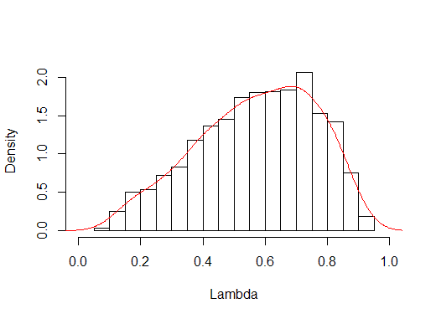

VPC

Figure A1: Posterior distribution of variance partition coefficient for LA random effects.

From Figure A1, an LA’s neighbouring LAs tends to (weakly) have a higher influence on the estimation of chlamydia testing in the previous year than the non-spatial structured LA level random effects.

*Estimation of joint distribution*

As discussed in the main text, the joint distribution of demographic and risk factors is estimated by combining conditional distributions obtained from available resources.

Due to limitations in the available data we make the following approximations,

$$p\left(age,sex,ethnic,student,livealone,LA\right)≈p\left(age,sex,LA\right)×p\left(ethnic | age,sex,LA\right)×$$

$$\frac{p\left(student | LA\right)}{E_{LA}[p\left(student|LA\right)]}×p(student|age,sex)×\frac{p\left(livealone | LA\right)}{E_{LA}[p\left(livealone|LA\right)]}×p(livealone|age,sex)$$

*Accounting for repeat testing within a year*

Repeat testing statistics are taken from 1, which gives the number of test per person in a given year in the NCSP and GUMCAD data sets.

We required the total number of people that test in that year so needed to remove those people who were repeat testing. Without any loss of generality, let us assume that there are only one or two tests per person. The proportion of recorded tests which are first visits in a year is

$$prop\left(1 test\right)+\frac{prop\left(2 tests\right)}{2}$$

For males and females combined and NCSP data set 1,

|  |  |
| --- | --- |
| **Number of tests per person in 2010** | **Proportion** |
| 1 | 91% |
| 2 | 8% |

Thus, the adjustment is 91 + 8/2 = 95%. This proportion is used to scale the observed number of tests in the surveillance data, which is then compared with the MRP predictions.

Alternatively, it may be natural not to think in terms of scaling down the number of observed tests in the surveillance data but rather scaling up the population size to account for repeat testing to give an *effective* population size. In this case, we want the expected number of additional tests for an individual $i$.

$$E\left[number of new tests\right]=\sum{i P(number of tests=i+1)}$$

Where, e.g.

$$P\left(number of tests=2\right)=\frac{\frac{prop\left(2 tests\right)}{2}}{prop\left(1 test\right)+\frac{prop\left(2 tests\right)}{2}}$$

Generally,

$$\sum{\frac{prop\left(i tests\right)}{i}}=\frac{1}{1+E\left[number of new tests\right]}$$

We could further use subsets, e.g. GUMCAD and NCSP specific values, to calculate a weighted average depending on the relative amount of testing done in each testing venue for a given area e.g. LA. In practice, because the numbers are similar, this makes very little difference to the results.

*Generalisations of the model*

We also investigated the effect on model performance of separating-out those individuals who had not had sex in the previous year and had not tested for chlamydia and those that had had sex and not tested2. It may be that for particular covariate values, those individuals who had had sex would test. Of course, the reason for them having sex are also associated with the same group of covariates. Thus, we fit two logistic models, firstly with a response variable of whether they have had sex in the previous year and secondly whether they have tested for chlamydia in the previous year using only the sample of individuals who have had sex. The post-stratification equation is then

$$p_{la}^{tested}=\frac{\sum_{j∈S}{N_{j} p_{j}^{hadsex}p_{j}^{tested}}}{\sum_{j∈S}{N_{j}^{}}}$$

A further generalisation is to include in the data model additional covariate values for which we do not have LA level data available with which to perform post-stratification. In this case, we can replace the missing values with the expected value from a second fit regressing the missing value variable on the remaining covariates. For example, if we wished to include the covariate ‘if an individual had sex in the previous year’ (*sex1yr*)

$$Pr\left(y_{i}=1\right)={logit}^{-1}(β^{0}+α_{j\left[i\right]}^{age}+α_{i}^{male}{male}_{i}+α_{k\left[i\right]}^{ethnicity}+α_{i}^{student}{student}_{i}$$

$$+α_{i}^{livealone}{livealone}_{i}+α_{m[i]}^{la}+α_{i}^{sex1yr}{sex1yr}_{i})$$

And

$$Pr\left({sex1yr}_{i}=1\right)={logit}^{-1}\left(β^{0}+α_{j[i]}^{age}+α_{i}^{male}{male}_{i}+α_{k[i]}^{ethnicity}+α_{i}^{student}{student}_{i}+α_{i}^{livealone}{livealone}_{i}+α_{m[i]}^{la}\right)$$

*Small numbers of observations*

Generally, a binomial-logit model will suffice, as used in this analysis, but in applications where various marginal distributions in the data have few observations a quasi-Poisson distribution may be appropriate 3.

*Model validation*

Multi-collinearity was detected using the generalised variance inflation factor (GVIF) 4. A GVIF 2 - 5 indicates mild multi-collinearity. From Table 2 we see that there was little multi-collinearity in the model parameter.

|  |  |  |
| --- | --- | --- |
| **Variable** | **GVIF** | **Degrees of Freedom** |
| Sex | 1.023 | 1 |
| Age | 1.359 | 1 |
| Ethnic group | 1.139 | 5 |
| Live alone | 1.043 | 1 |
| Student | 1.33 | 1 |
| Conception decile | 2.416 | 9 |
| Urban-Rural classification | 1.563 | 1 |
| IMD upper quartile | 2.092 | 1 |
| Government region | 1.309 | 1 |

Table A2: Generalised Variance Inflation Factor for each covariate used in the multilevel regression with post-stratification model.

*Order of operations in MRP calculation*

Depending on at which point we reduce the posterior distribution down to a point estimate may (slightly) alter the point estimate. That is, we may use the maximum a-posterior (MAP) estimates from the posterior distribution fitting to Natsal-3 data to calculate the final post-stratified LA level estimates

$$E_{LA}\left[{\hat{θ}}_{MAP}\right]$$

Alternatively, we can propagate forward the whole posterior sample obtained from WinBUGS 5 and then take expectation at the very end

$$\hat{E_{LA}\left[θ_{i}^{*}\right]}$$

*Exploratory data analysis plots*

Figure A2 shows the scatterplots of LA level continuous covariates and a histogram for discrete values covariates against 2011 NCSP coverage.

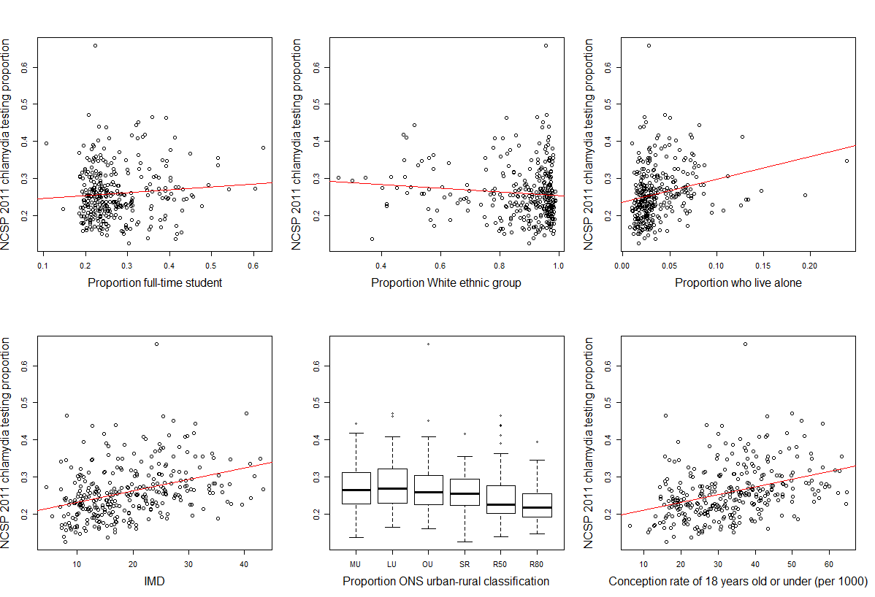

Figure A2: Scatterplots of LA level covariates and a boxplot for discrete values covariates against 2011 NCSP coverage. Linear regression fits are shown by red lines.

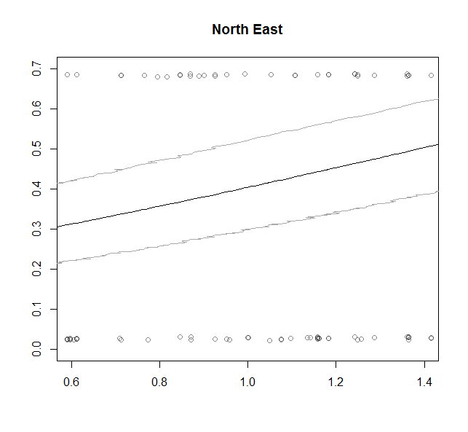 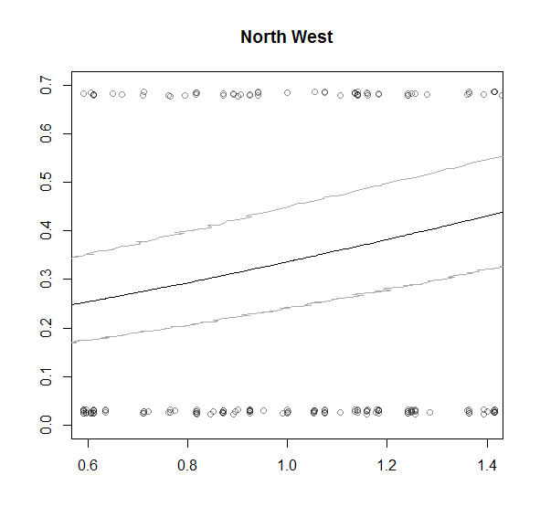 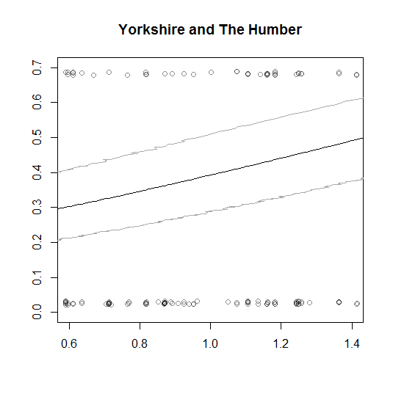 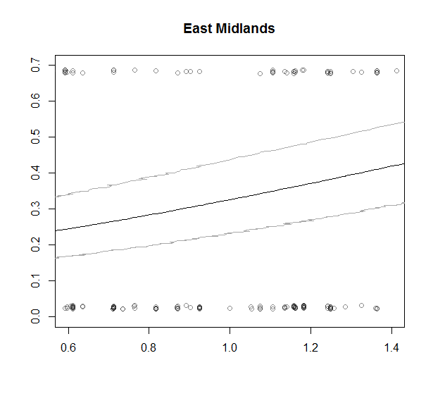 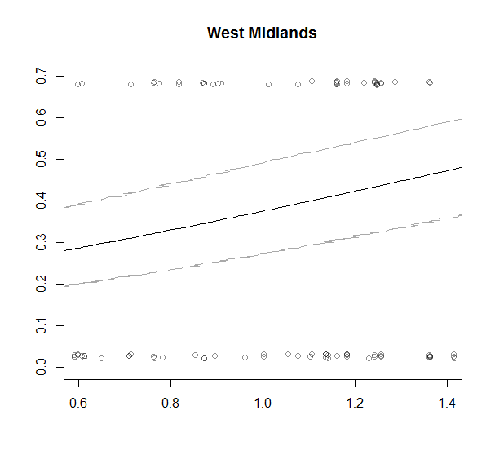 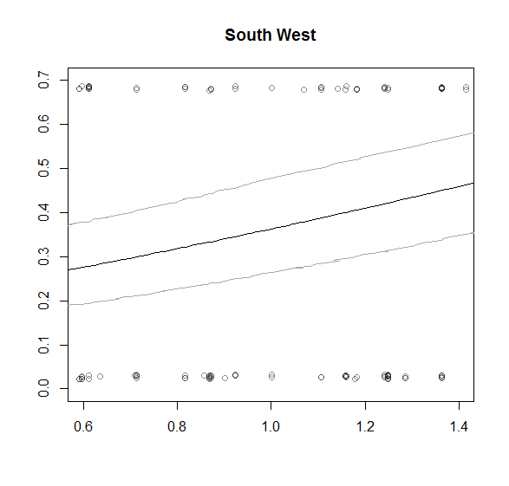 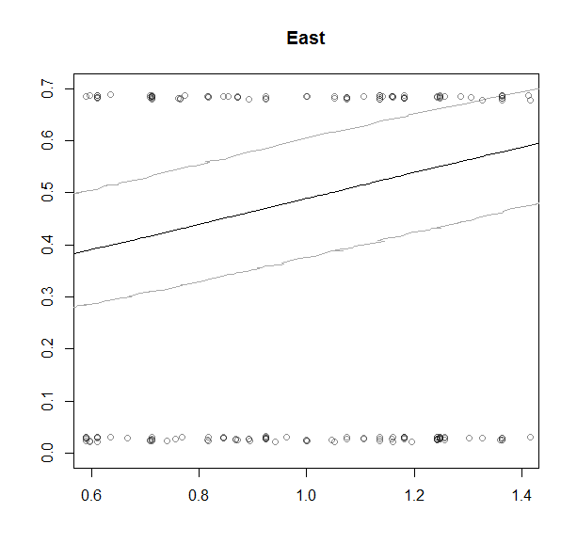 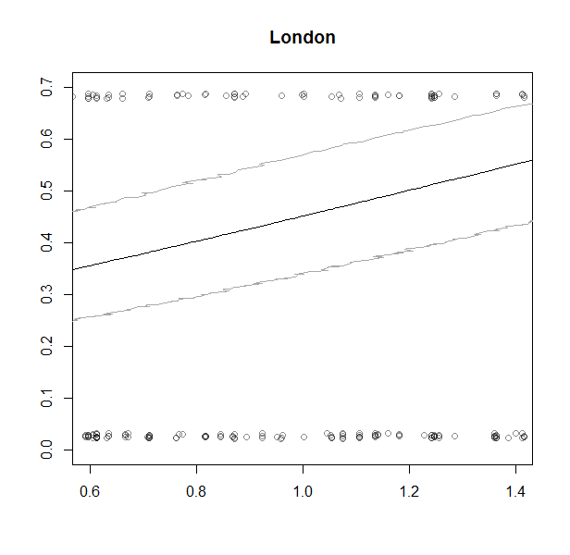 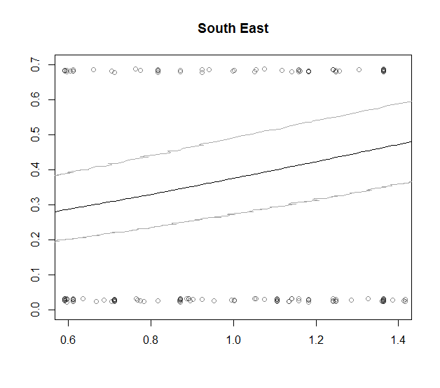

Figure A3: Logistic model predictions for the probability of testing for chlamydia stratified by government region. The bold central line is the mean predicted probability and the lighter lines are the 2 standard error upper and lower bounds 6. Points at probability 0 and 1 are the direct Natsal-3 values for whether an individual was tested for chlamydia in the previous year. The x-axis values are the logistic model fits for the model without government region.

* The probability of testing for chlamydia in the last year ranges from about 30% to 50% within government regions.
* East and London have a relatively higher upper value of over 50%.

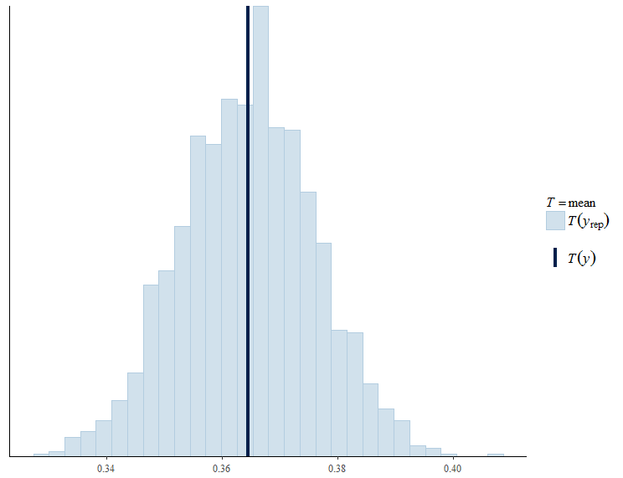

Figure A: Distribution of the pooled proportion of individuals who tested for chlamydia over the replicated datasets from the posterior predictive distribution and compared to the observed total proportion in Natsal-3.

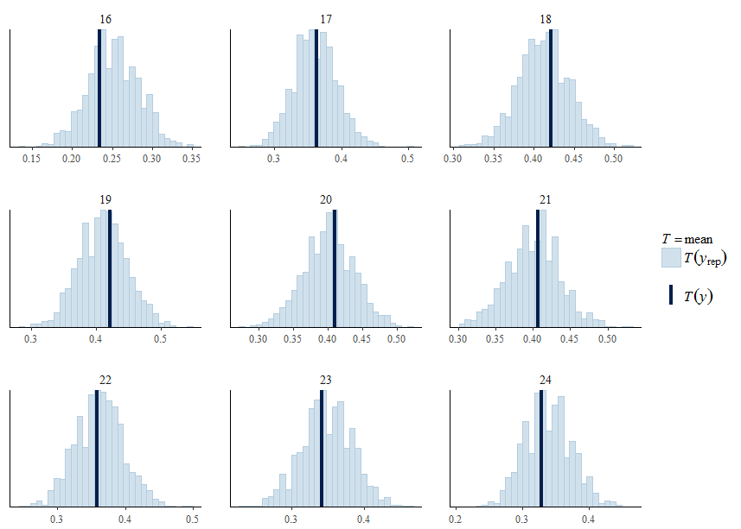

Figure A: Distribution of the proportion of individuals who tested for chlamydia by age group over the replicated datasets from the posterior predictive distribution and compared to the observed proportion in Natsal-3.

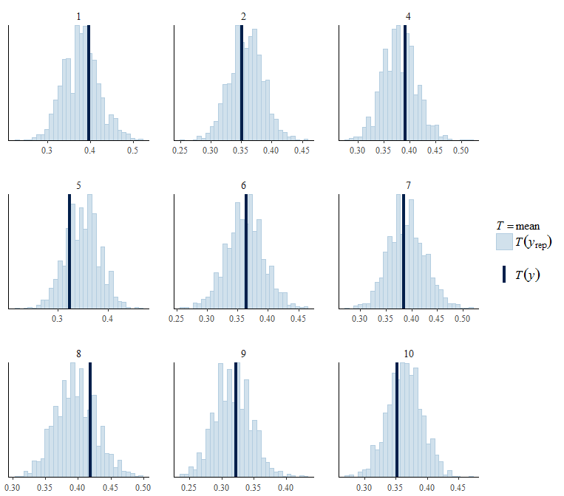

Figure A: Distribution of the proportion of individuals who tested for chlamydia by region over the replicated datasets from the posterior predictive distribution and compared to the observed proportion in Natsal-3.

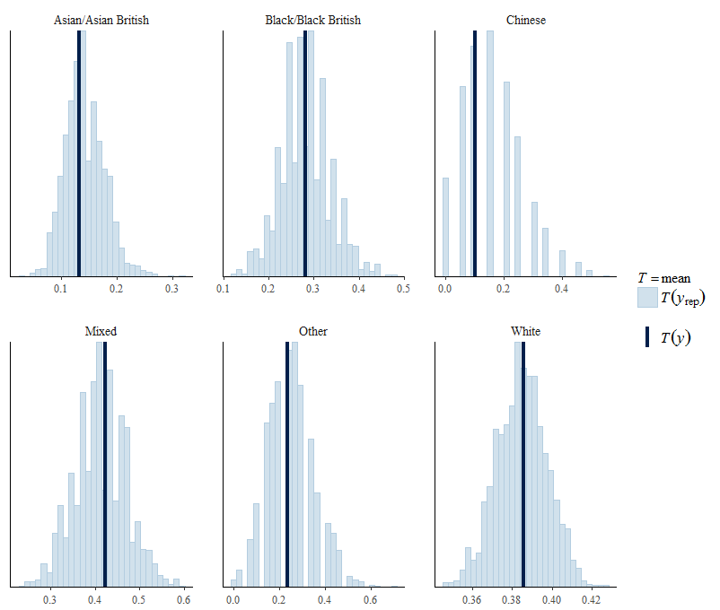

Figure A: Distribution of the proportion of individuals who tested for chlamydia by ethnic group over the replicated datasets from the posterior predictive distribution and compared to the observed proportion in Natsal-3.

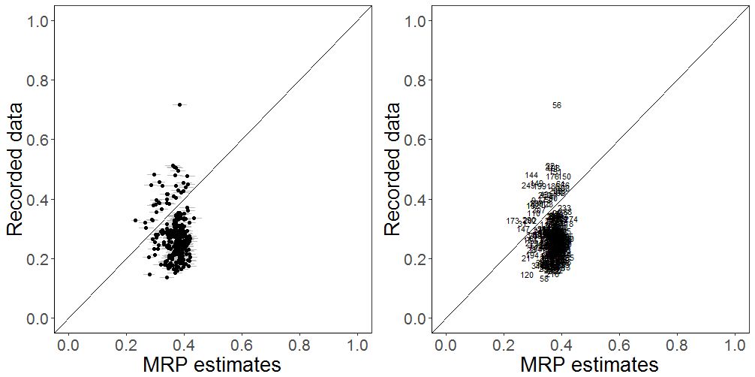

Figure A8: Posterior predictions of chlamydia testing coverage in the previous year, showing the 50% Credible Intervals (grey lines) for each LA propagating forward the uncertainty associated with each parameter estimate. Black points are the maximum a-posteriori estimates. The number represent different LAs (see Table A1 for names).

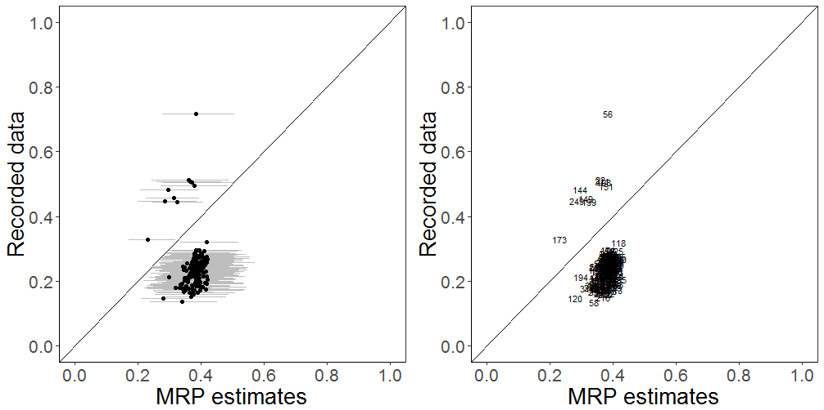

Figure A9: Posterior predictions of chlamydia testing coverage in the previous year, showing the 99% Credible Intervals (grey lines) for each LA propagating forward the uncertainty associated with each parameter estimate. Black points are the maximum a-posteriori estimates. The number represent different LAs (see Table A1 for names).

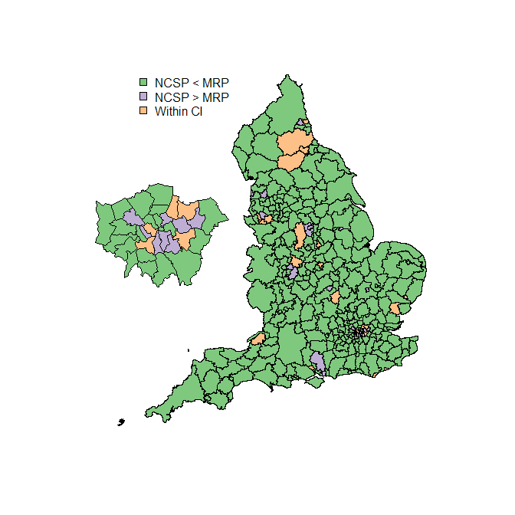

Figure A10: A choropleth map of England by LA. LAs within (orange) and outside of the posterior distribution 50% credible interval. Higher MRP estimates to NCSP 2011 are in green and lower MRP estimates to NCSP 2011 are in purple. The majority of the time the MRP over-estimates testing relative to recorded testing.

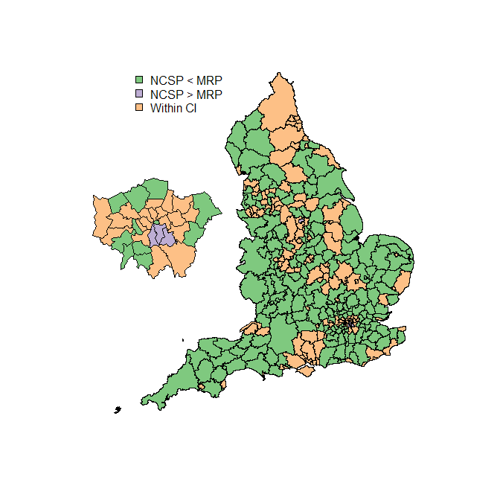

Figure A11: A choropleth map of England by LA. LAs within (orange) and outside of the posterior distribution 99% credible interval. Higher MRP estimates to NCSP 2011 are in green and lower MRP estimates to NCSP 2011 are in purple. MRP model estimates generally over-estimated relative to registered testing for more rural regions of England but within the 99% credible intervals in more urban places like London and Manchester, for example.

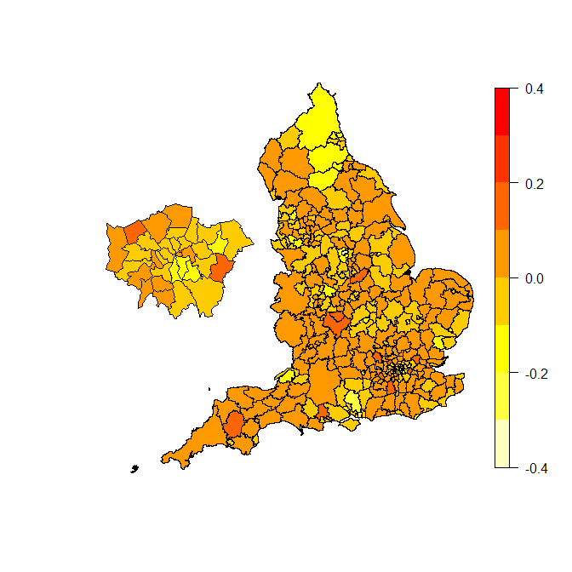

Figure A12: A choropleth map of England by LA of the difference between the national mean and each LAs chlamydia testing in the previous year (coverage) from the recorded testing NCSP 2011.



Figure A13: Estimated chlamydia testing coverage in the previous year for MRP against NCSP 2011 surveillance data, stratified by government region. The diagonal lines represent equality. The numbers correspond to different LAs (see Table A1 for names).

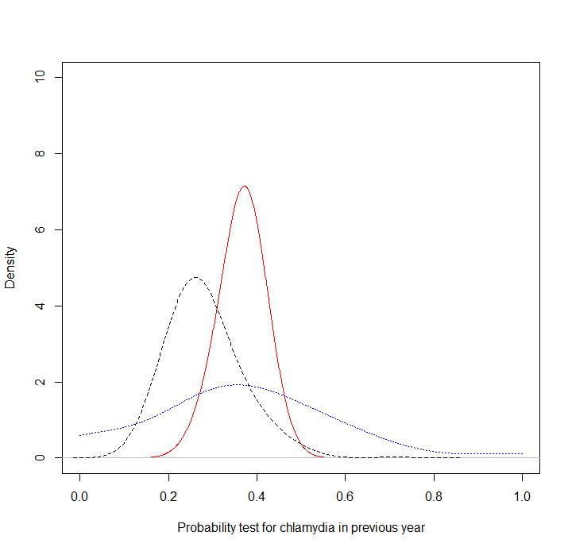

Figure A: Distributions of probability testing for chlamydia in previous year by LA for i) MRP estimation (solid red line); ii) Natsal-3 direct estimate (dotted blue line) and (iii) NCSP 2011 (dashed black line).

|  |  |  |  |  |  |  |  |  |
| --- | --- | --- | --- | --- | --- | --- | --- | --- |
| **Model formula** | **Df** | **AIC** | **BIC** | **Log-likelihood** | **Deviance** | $$χ^{2}$$ | $χ^{2}$**Df** | **Pr(> $χ^{2}$)** |
| cttestly ~ 1 + (1 | age) | 2 | 7814.38 | 7829.04 | -3905.19 | 7810.38 | - | - | - |
| cttestly ~ 1 + (1 | gor) | 2 | 9794.58 | 9809.24 | -4895.29 | 9790.58 | 0.00 | 0 | 1 |
| cttestly ~ 1 + sex | 3 | 9139.75 | 9161.73 | -4566.88 | 9133.75 | 656.83 | 1 | 7.31E-145 |
| cttestly ~ (1 | age) + sex | 3 | 4392.46 | 4414.44 | -2193.23 | 4386.46 | 4747.29 | 0 | 0 |
| cttestly ~ (1 | age) + sex + ethnic | 4 | 4389.91 | 4419.22 | -2190.95 | 4381.91 | 4.55 | 1 | 0.0329 |
| cttestly ~ (1 | age) + sex + student | 4 | 4390.50 | 4419.82 | -2191.25 | 4382.50 | 0.00 | 0 | 1 |
| cttestly ~ (1 | age) + sex + Livealone | 4 | 4380.01 | 4409.32 | -2186.01 | 4372.01 | 10.49 | 0 | 0 |
| cttestly ~ (1 | age) + sex + ethnic:student | 5 | 4389.96 | 4426.60 | -2189.98 | 4379.96 | 0.00 | 1 | 1 |
| cttestly ~ sex + (sex | age) | 5 | 4394.77 | 4431.41 | -2192.39 | 4384.77 | 0.00 | 0 | 1 |
| cttestly ~ sex + (student | age) | 5 | 4389.86 | 4426.50 | -2189.93 | 4379.86 | 4.91 | 0 | 0 |
| cttestly ~ sex + (ethnic | age) | 5 | 4389.39 | 4426.03 | -2189.70 | 4379.39 | 0.46 | 0 | 0 |
| cttestly ~ sex + (Livealone | age) | 5 | 4390.29 | 4426.93 | -2190.14 | 4380.29 | 0.00 | 0 | 1 |
| cttestly ~ (1 | age) + sex + ethnic + student + Livealone | 6 | 4376.27 | 4420.23 | -2182.13 | 4364.27 | 16.02 | 1 | 6.26E-05 |
| cttestly ~ (1 | age) + sex + ethnic + student + Livealone + (1 | gor) | 7 | 4378.27 | 4429.56 | -2182.13 | 4364.27 | 0.00 | 1 | 1 |
| cttestly ~ (1 | age) + sex + ethnic + student + Livealone + (1 | gor) + (1 | Conception.decile) | 8 | 4379.90 | 4438.53 | -2181.95 | 4363.90 | 0.36 | 1 | 0.547847808 |
| cttestly ~ (1 | age) + sex + ethnic + student + Livealone + (1 | gor) + (1 | `Numerical classification`) | 8 | 4380.27 | 4438.89 | -2182.13 | 4364.27 | 0.00 | 0 | 1 |
| cttestly ~ (1 | age) + sex + ethnic + student + Livealone + (1 | gor) + UpperQ_IMD | 8 | 4380.10 | 4438.73 | -2182.05 | 4364.10 | 0.16 | 0 | 0 |
| cttestly ~ (1 | age) + sex + ethnic + student + Livealone + (1 | gor) + (1 | metcounty_UA) | 8 | 4379.64 | 4438.27 | -2181.82 | 4363.64 | 0.46 | 0 | 0 |
| cttestly ~ (1 | age) + sex + ethnic + student + Livealone + (1 | gor) + (1 | Conception.decile) + (1 | `Numerical classification`) + UpperQ_IMD + (1 | metcounty_UA) | 11 | 4385.38 | 4465.98 | -2181.69 | 4363.38 | 0.27 | 3 | 0.965860357 |

Table A: Multi-level logistic regression model selection statistics using combined Natsal-3, administrative and ONS data.

‘Livealone’ variable is included to account for Natsal-3’s complex survey design which included household size. Very little research has been carried-out focusing on the relationship between household size and sexual health or sexual behaviour. An association has been shown between not living with family and having had an STI in girls7.

**References**

1. Woodhall, S. C. *et al.* Repeat genital Chlamydia trachomatis testing rates in young adults in England, 2010. *Sex. Transm. Infect.* 51–56 (2013).

2. Park, D. K., Gelman, A. & Bafumi, J. Bayesian Multilevel Estimation with Poststratification : State-Level Estimates from National Polls. *Polit. Anal.* **12,** 375–385 (2004).

3. Ghitza, Y. & Gelman, A. Deep Interactions with MRP: Election Turnout and Voting Patterns Among Small Electoral Subgroups. *Am. J. Pol. Sci.* **57,** 762–776 (2013).

4. Fox, J. & Monette, G. Generalized Collinearity Diagnostics. *J. Am. Stat. Assoc.* **87,** 178–183 (1992).

5. Lunn, D. J., Thomas, A., Best, N. & Spiegelhalter, D. WinBUGS – a Bayesian modelling framework: concepts, structure, and extensibility. *Stat. Comput.* **10,** 325–337 (2000).

6. Park, D. K., Gelman, A. & Bafumi, J. State-level opinions from national surveys: Poststratification using multilevel logistic regression. *Public Opin. State Polit.* 209–228 (2006).

7. Kim, S. & Lee, C. Factors Affecting Sexually Transmitted Infections in South Korean High School Students. *Public Health Nurs.* **33,** 179–188 (2016).